Aplia Homework: Consumer Choice: Individual and Market Demand Week-5 Part-2

1. Total and marginal monetary utility
Kenji enjoys drinking milk. The following table contains information about Kenji's total utility from milk. Fill in the missing cells in the table.
Milk | Total Utility | Marginal Utility
(Gallons per week) | (TU, $) | (MU, $)
0 | $0
 |  | __
1 | 16
 |  | __
2 | 28
 |  | __
3 | 37
 |  | __
4 | 43
 |  | __
5 | 46
 |  | __
6 | 47
Points:

On the following graph, use the green points (triangle symbol) to plot Kenji's total utility (TU) curve if he consumes zero, one, two, three, four, five, or six gallons of milk per week
Note: Plot your points in the order in which you would like them connected. Line segments will connect the points automatically. Remember to plot from left to right.

Suppose that the price of a gallon of milk is $6.
On the following graph, use the blue points (circle symbol) to plot Kenji's marginal utility (MU) curve from consuming his first six gallons of milk per week, as shown in the previous table. Also, place the orange line (square symbols) on the graph to show the price of a gallon of milk.
Note: Plot your points in the order in which you would like them connected. Line segments will connect the points automatically. Remember to plot from left to right.

When the price of a gallon of milk is $6, Kenji should purchase_______ of milk to maximize his total net utility.
For Kenji, increasing his consumption of milk results in_______ marginal utility of the additional unit.

2. Total and marginal net utility
The following table shows Frances's total utility from eating muffins.
Quantity (Q) | Total Utility | Marginal Utility
(Muffins per month) | (TU, $) | (MU, $)
0 | 0
 |  | __
1 | 9
 |  | __
2 | 17
 |  | __
3 | 23
 |  | __
4 | 28
 |  | __
5 | 30
 |  | __
6 | 24

If muffins were free, Frances would choose to eat_______ muffins per month.

Now (and for the rest of the question), assume that muffins cost $4 each.
On the following graph, use the green points (triangle symbols) to plot Frances's total utility if she buys 0, 1, 2, 3, 4, 5, or 6 muffins per month. Then use the purple points (diamond symbols) to plot her total net utility (that is, total utility minus total expenditure) for those same quantities.
Note: Plot your points in the order in which you would like them connected. Line segments will connect the points automatically. Remember to plot from left to right.
Hint: Don’t forget to include what happens at 0 muffins!

The following graph shows Frances's marginal utility (demand) curve. By comparing this graph with the previous one, you can see that Frances's marginal utility curve crosses the horizontal axis (indicating a marginal utility of zero) at a quantity of_______ muffins per month, which is the quantity at which her_______ is maximized on the previous graph.

Now use the black line (plus symbols) to draw a horizontal line at the price of $4.
Frances's marginal utility curve crosses this black line (price) line at a quantity of______ muffins per month, which is the quantity at which her______ is maximized on the previous graph.

On the second graph, use the colored rectangles to shade the consumer’s surplus (CS) Frances receives from each of the muffins she chooses to buy at a price of $4. You can place up to four rectangles on the graph; if she buys fewer than four muffins, don't add the rectangles that correspond to the muffins she doesn't buy.

3. Behavioral economics
The traditional economic framework assumes that people make rational economic decisions, that is, that they act in ways that maximize their utilities. However, behavioral economists have found evidence that is inconsistent with economists’ rationality assumptions.
Which of the following is an example of evidence of irrational behavior? (Note: Read carefully.)

Some stock market investors rush to invest their money when stock prices are rising rapidly.
Some people are willing to drive an extra mile to save $10 on a $50 purchase but not to save $5 on the same purchase.
A lower price tends to increase the number of buyers of a commodity.

4. Understanding opportunity cost
Before you started applying for college, a job recruiter offered you a full-time cashier position at a department store earning an after-tax salary of $24,000 per year. However, you turn down this offer and attend your first year of college. The additional monetary cost of college to you, including tuition, supplies, and additional housing expenses, is $38,000.
You decide to go to college, probably because________ .

5. Individual and market demand
Suppose that Dmitri and Frances are the only consumers of pizza slices in a particular market. The following table shows their weekly demand schedules:
Price | Dmitri's Quantity Demanded | Frances's Quantity Demanded
(Dollars per slice) | (Slices) | (Slices)
1 | 8 | 16
2 | 5 | 12
3 | 3 | 8
4 | 1 | 6
5 | 0 | 4
On the following graph, plot Dmitri's demand for pizza slices using the green points (triangle symbol). Next, plot Frances's demand for pizza slices using the purple points (diamond symbol). Finally, plot the market demand for pizza slices using the blue points (circle symbol).
Note: Plot your points in the order in which you would like them connected. Line segments will connect the points automatically. Remember to plot from left to right.

6. Demand terminology
Complete the following table by selecting the term that matches each definition.
Definition | Quantity Demanded | Demand Curve | Demand Schedule | Law of Demand
A table showing the relationship between the price of a good and the amount that buyers are willing and able to purchase at various prices | ___ | ___ | ___ | ___
The claim that, other things being equal, the quantity demanded of a good falls when the price of that good rises | ___ | ___ | ___ | ___
A graphical representation of the relationship between the price of a good and the amount of the good that buyers are willing and able to purchase at various prices | ___ | ___ | ___ | ___
The amount of a good that buyers are willing and able to purchase at a given price | ___ | ___ | ___ | ___

Apply your understanding of the previous key terms by completing the following scenario with the appropriate terminology.
Your friend Crystal really struggles with understanding graphs. She shows you the following illustration and asks for your help interpreting it:
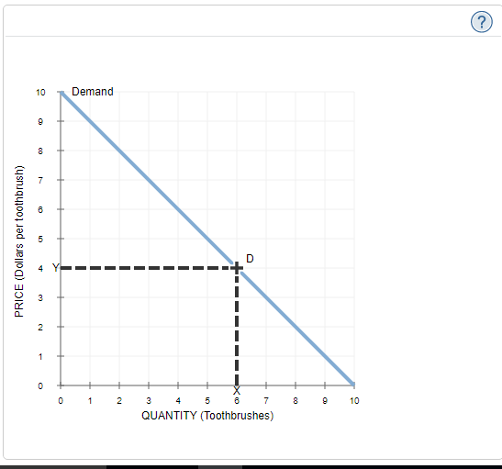

Fortunately, you recognize that the line on this graph is_______. When your friend asks you which value represents the quantity of toothbrushes demanded at a price of $4 per toothbrush, you tell her the value represented by the letter_______.

7. An individual's budget
Suppose Ana has a weekly budget of $48 to spend on milk and yogurt. Milk is priced at $4 per gallon, and yogurt is priced at $2 per container.
If Ana spends her entire $48 on milk, she can buy____ gallons of milk. If she spends her entire $48 on yogurt, she can buy____ containers of yogurt.

Use the blue line (circle symbol) to plot Ana's budget line on the following graph. Next, use the orange point (square symbol) to shade the area that represents combinations of milk and yogurt for which Ana does not need to spend all of her income to consume. Finally, place the black point (plus symbol) on the point on Ana's budget line that corresponds to a scenario in which Ana spends $24 on each good.
Note: Dashed drop lines will automatically extend to both axes.

What does the slope of Rina's budget line represent?

The cost of an additional box of cereal in terms of dollars
The cost of an additional gallon of juice in terms of dollars
The opportunity cost of an additional gallon of juice in terms of boxes of cereal
The opportunity cost of an additional box of cereal in terms of gallons of juice

Suppose Ana receives $12 from her grandmother and decides to dedicate this money to buying more milk and yogurt.
Using the green line (triangle symbol), draw Ana's new budget line on the previous graph.
Close Explanation
Explanation:

True or False: Rina faces a new tradeoff between juice and cereal.

True
False

8. Shifts in a budget line
Jake brings $40 to a football game to spend on sodas and pizza. The following diagram shows his budget line:

According to the diagram, sodas cost___ each, and pizza costs___ per slice.

Adjust the diagram to show how Jake's budget line would change if he had brought more money to the stadium. (Assume the prices of sodas and pizza remain the same.)
Note: Select either end of the budget line on the graph to make the endpoints appear. Then drag one or both endpoints to the desired position. Points will snap into position, so if you try to move a point and it snaps back to its original position, just drag it a little farther.

9. Calculating the marginal rate of substitution (MRS)
Maria enjoys eating muffins and scones. The following graph displays one of Maria's indifference curves, which show her preference for scones and muffins per month. Points A, B, C, and D represent points on the same indifference curve. For example, point A represents a point on the indifference curve corresponding to 10 muffins and 70 scones per month.
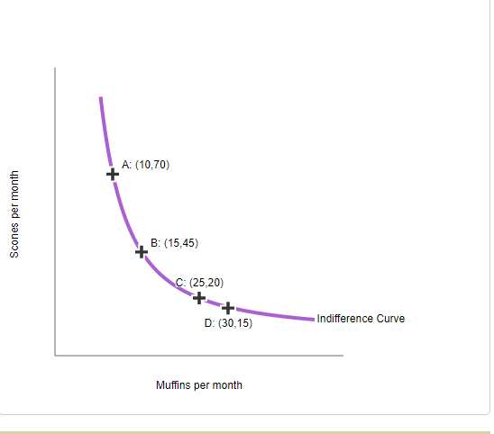

Between points A and B, Maria's marginal rate of substitution is_____ per muffin.
Between points C and D, Maria's marginal rate of substitution is_____ per muffin.

10. Indifference curves and utility maximization
Alex is in a band and likes to advertise upcoming shows using flyers he posts around the city. Making one black-and-white flyer costs $0.05, and making a flyer in colour costs $0.10. Alex budgets $25.00 for making flyers each month.
The following graph shows three of Alex's indifference curves for the number of black-and-white and colour flyers that he makes.
Use the green line (triangle symbol) to plot Alex's budget line. Then, place the black point (plus symbol) on the graph to indicate Alex's optimal consumption choice given that budget line.

At the optimum that you indicated on the graph, Alex's marginal rate of substitution is equal to_______ in black and white per flyer in colour.

11. Normal and inferior goods
Eileen enjoys going to the theatre to see plays, and she also enjoys going to rock concerts. The following diagram shows two of Eileen's indifference curves for going to plays and concerts. Given Eileen's initial budget line (BL1BL1), she chooses to go to four concerts and six plays per month (point A). Then, after a reduction in pay, Eileen's income decreased while the prices of theatre and concert tickets remained the same, causing her budget line to shift.
On the following graph, shift Eileen's budget line to reflect the change in income. Then use the black plus sign to indicate the new combination of plays and concerts that maximize Eileen's utility.

Based on Eileen's new consumption of plays and concerts after her budget line has shifted, plays are_______ good and concerts are_______ good.

12. Deriving demand from an indifference map
Kate lives in San Diego and enjoys drinking lattes and eating scones. The price of a latte is held constant at $4 throughout this problem.
On the following diagram, the purple curves (I1I1 and I2I2) represent two of Kate's indifference curves. The line BL1BL1 shows her initial budget line. Point X show Kate's optimum consumption bundles subject to her initial budget line.
Suppose the price of scones increases.
On the following graph, use the green line (triangle symbol) to draw Kate's new budget constraint, tangent to the indifference curve I2I2. Then use the black plus symbol to indicate the new optimal bundle of scones and lattes that Kate chooses after the price change.
Hint: You can see the slope, horizontal intercept, and vertical intercept of each budget line by clicking on it.

Given the previous graph and knowing the price of a latte is $4, Kate's income must be_____.

.

Using Kate's income that you previously computed, complete the following table by finding the price of a scone when BL1BL1 represents Kate's budget line and when BL2BL2 represents her budget line. Then indicate the quantity of scones consumed in each of those scenarios.
When Kate's budget line is... | Price | Consumption
 | (Dollars per scone) | (Scones)
BL1BL1 | __ | __
BL2BL2 | __ | __
Given the price-quantity combinations from the previous table, use the blue line (circle symbol) to plot Kate's demand for scones on the following graph.
Hint: Assume that Kate's demand for scones is a straight line. You should derive two points on the demand curve from the preceding graph. Then place the blue line on the following graph so that it passes through these two points.

